Evaluation Plan #1 – 75 Minutes

Drill Name & Description |  | 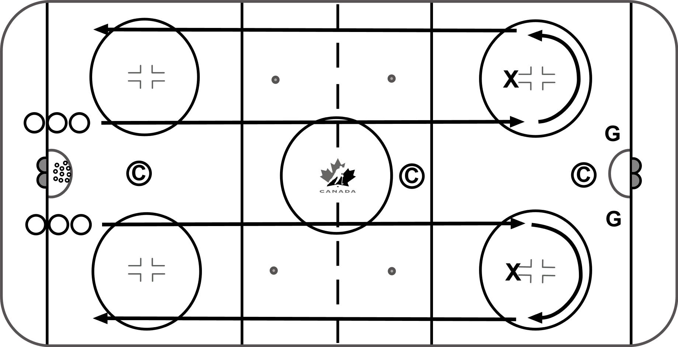  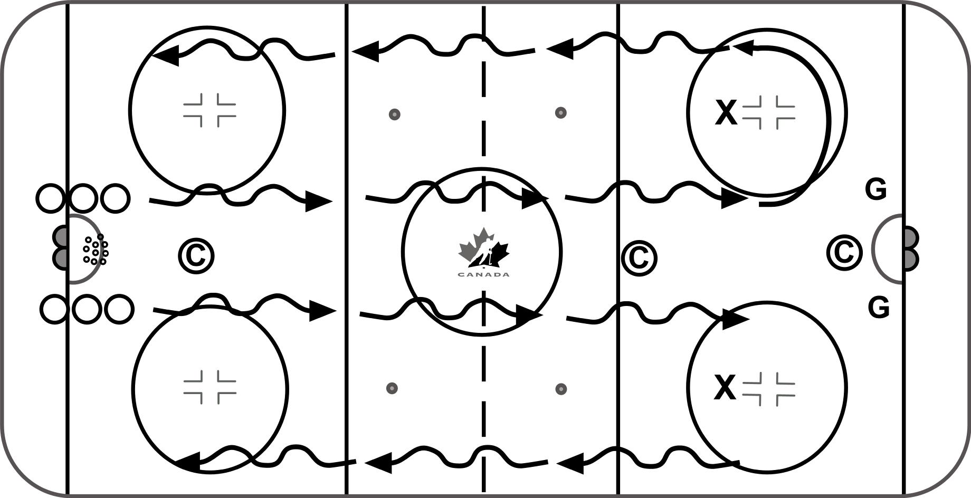
12 mins – Skating / Puck Control Agility Combinations
-Form two lines at hash marks in one end, players perform skills down the middle of the ice and back along the boards.

-Players go one after another

-Forwards and Defence do the same skills

Forward Skating skills to be done: NO PUCK / ADD PUCK
- Heel skate
- Heel skate / stride combination
- Heel skate / 1 crossover combination
- Stride / 1 crossover combination
- Continuous Crossovers

Key Teaching Points |  | Key Evaluation Points
Skating  -Encourage creativity / deceptive skating  -Change direction / Lateral Movements  -Quick feet  -Head up  -Technique is important in the warm-up to give the players lots of repetition on technical aspects of skating | Puck Control  -Focus on the blending skills with a puck  -Progress to crossovers  -Progress to Mohawks  -Deceptive skating moves with puck  -Don’t rush through the blended skills | Skating  -Eyes up, scan the ice  -Look for equal ability with both feet  -Look for agility, quickness, speed change  -Puck Placement | Puck Control  -Eyes up, scan the ice  -Range of motion to forehand and backhand  -Separation of upper and lower body  -Agility, creativity, deception  -Puck Management – puck not exposed

Drill Name & Description | 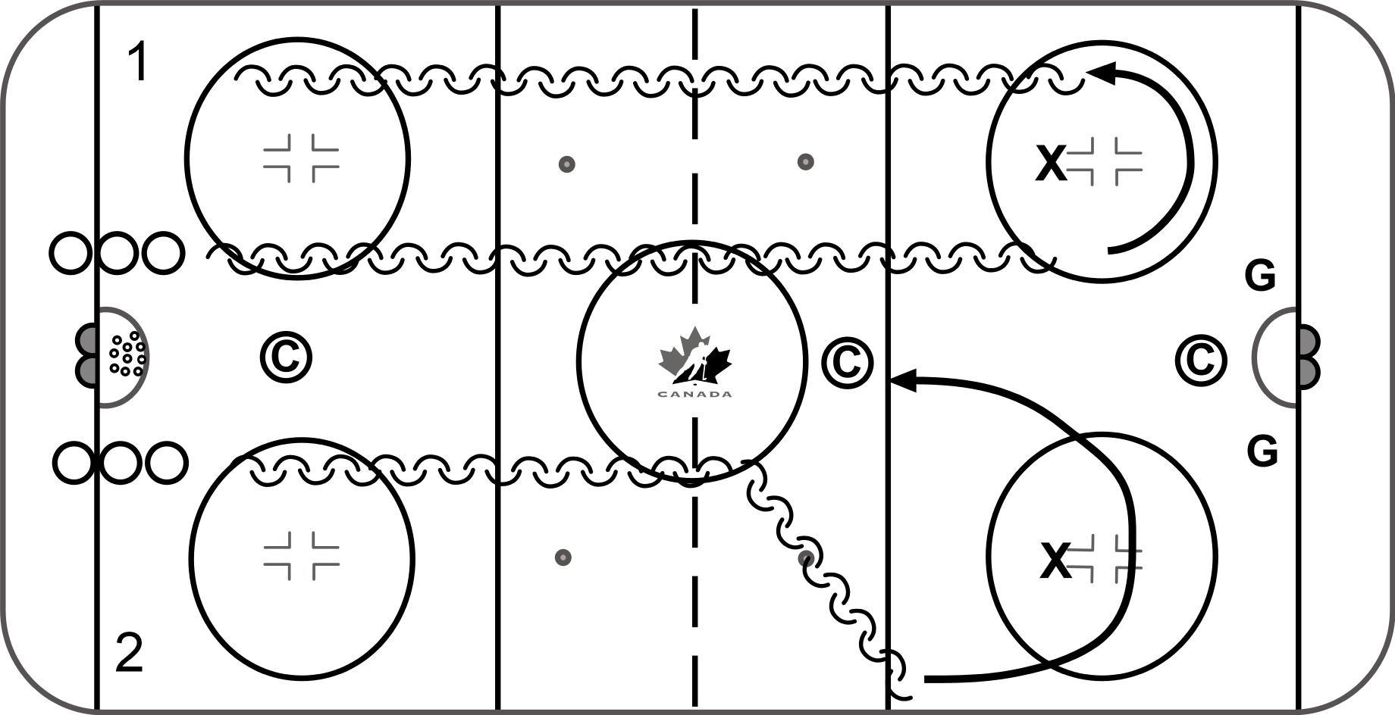
8 mins – Skating Warm Up – Backward Skating
-Players line up in two lines on the hashmarks.
-Both lines can go at the same time, or each line can alternate, skating down the middle to the pylon and then back along the boards.

-Players go one after another
-Forwards and Defence do the same skills

Backward Skating skills to be done:
Pattern 1
- Backwards, alternating c-cut holds
- Backwards, one crossover reach
- First player bwds, Second Player fwds – mirror / contain
Pattern 2
- Backwards, Scull to outside blue line
- Backwards, open hips to outside blue line

Key Teaching Points | Key Evaluation Points
-Good knee bend – stay low  -Strong push and recover  -Efficiency (feet under control) over speed  -Technique is important in the warm-up to give the players lots of repetition on technical aspects of skating | -One hand on stick, out in front  -Eyes up, scan the ice  -Minimize unnecessary crossovers  -Efficient feet, quiet upper body

Drill Name & Description |  | 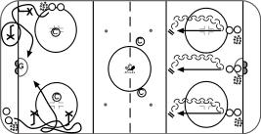
12 mins – Skill Splits
- Forwards – Small Area Puck Control
- Place two ‘danglers’ in corner on one side and parallel to boards on the other
- One side attacks goal line (down) / Other side attacks seam (up)
- On the whistle, players leave the corner with a puck skating around the danglers in a figure 8 pattern working on different skills.
- Alternate sides to avoid multiple shots on goaltender at same time. (Can place 2 nets on goal line for shots from both sides)

Puck Control Skills to be done:
- Random Moves
- Random Moves - Add Chaser
- Random Moves – Give and Go Passing
- Random Moves - No Pylons – Add Chaser

- Defence – Transition Pivots

Transition Skills to be done: 2 or 3 reps without puck, then add puck
- Toes first
- Heels first
- Ride inside edge
- Repeat each sequence above with give and go pass from coach
Key Teaching Points |  | Key Evaluation Points
Forwards  - Try to keep your head up as much as possible.  - Speed is not important, do the drill correctly and work on technique before increasing speed. | Defence  -Players need to have a good knee bend for balance  -Keep eyes up, chest up, shoulders back  -Limit the crossing of the feet as much as possible coming out of transition  - Heels first then, toes first, ride edge at bottom of pivot | Forwards  -Skating edgework  -Creativity, puck placement  -Scan ice, eyes up, see the next play  -Attack for quick move or shot | Defence  -Turn heels and hips, 1 x-over out, then start striding  -Head up and shoulders square  -Toes around apex before turning to go bwds  -Watch for equal ability to each side  -Open hip, ride inside edge to fwds – no x-over

Drill Name & Description |  | 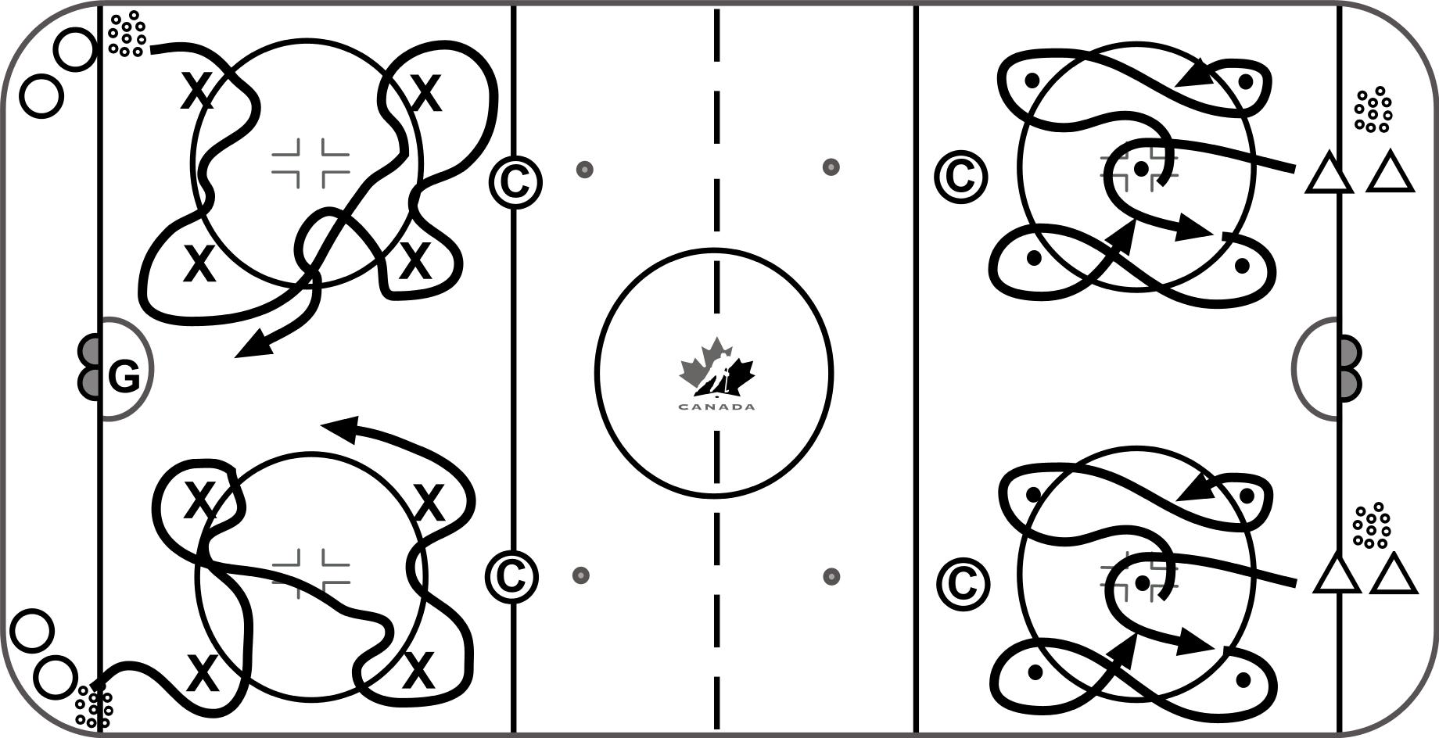
12 mins – Skill Splits
- Forwards – 4 Pylon Agility
-Place 4 pylons around a circle
  - Player starts by going around the pylons in a random fashion.
  - Two players One puck
  - One player one chaser
  - Progress to no pylons / keep away

-Alternate sides - finish with shot on net (can use two nets on goal line if more than 2 goalies in the group)

- Defence – 5 Puck Agility
-Place 5 pucks in circle as shown.
-Player must skate around each of the outside pucks, and always come back to the middle before skating around one of the outside pucks again, toes always pointing forward during transitions
- No Puck
- Add Puck
- Add pass to coach in front
- Remove pucks used as markers - Progress to pressure from coach
Key Teaching Points |  | Key Evaluation Points
Forwards  -Keep the feet moving  -Creativity / Change of direction  -Quick hands and feet  -Scan the ice front and behind | Defence  -Quick feet, stay low for balance  -Efficient movements ie try to do only 1 crossover to get back to middle  -Scan the ice front and behind | Forwards  -Deception, fakes  -Eyes up  -Make turns with both edges  -Accelerate out with puck protection | Defence  -Turn heels and hips, 1 crossover out  -Head and shoulders up ice - square  -Toes around apex before turning to go bwds  -Look for equal ability both ways  -Open hip, ride inside edge to fwd-no x-over  -Keep bottom hand on stick, load puck

Drill Name & Description |  | 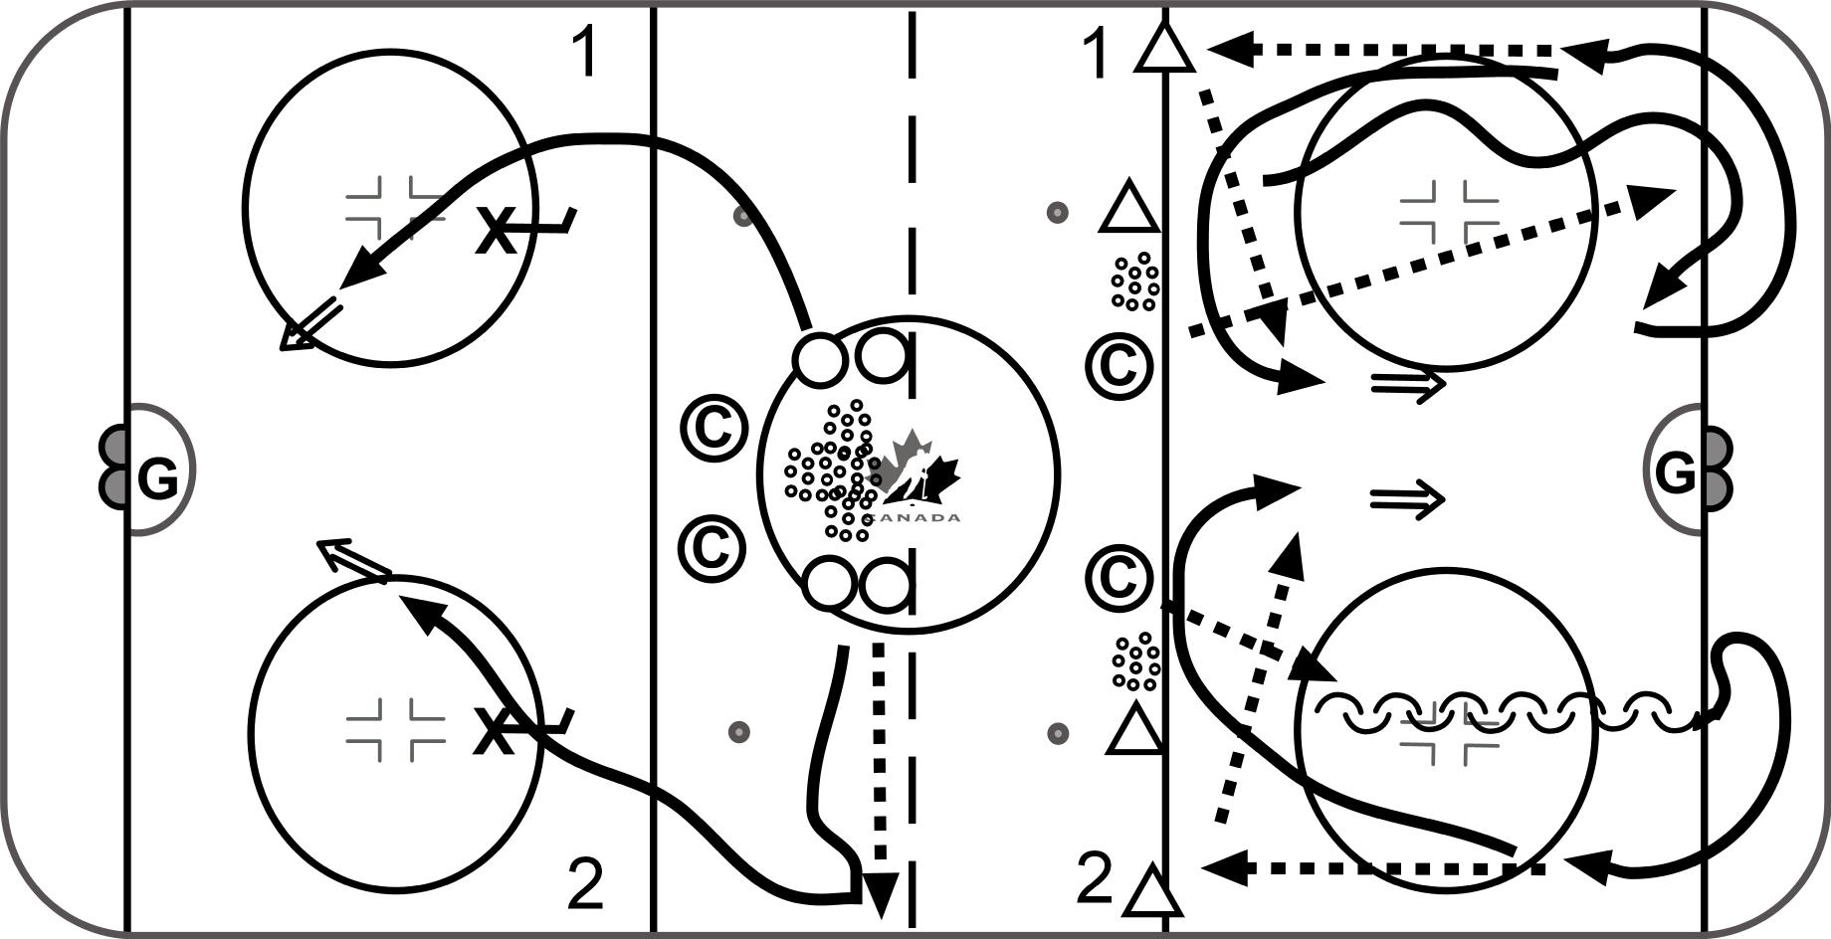  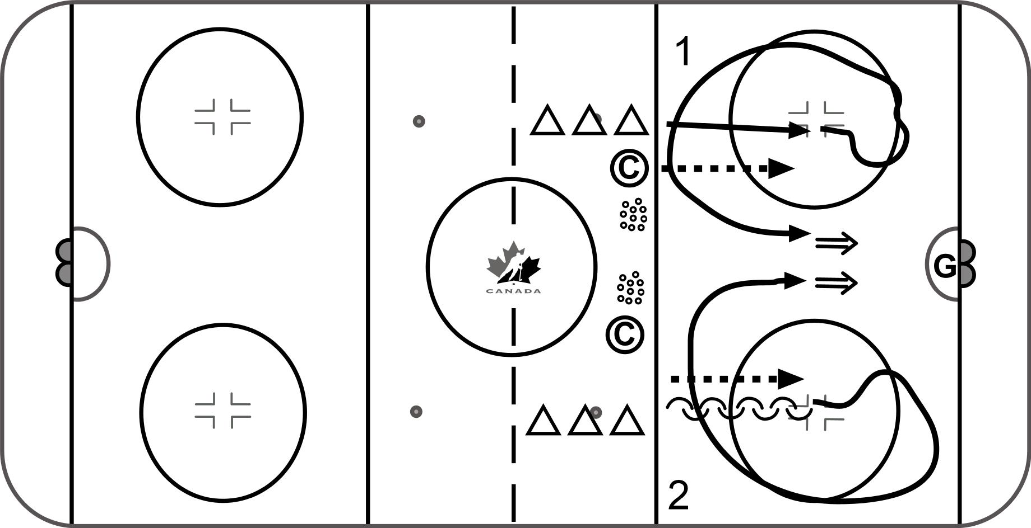
12 mins – Skill Splits
1) Forwards – Shooting Sequence (off retrieval)
-Players line up at centre ice. Place obstacle inside top of each circle
-Player’s alternate spotting a puck to the side wall. Retrieve puck then skate towards the obstacles and performing a shooting skill.
Shooting Skills involved:
- Shoot off inside leg
- Shoot off outside leg
- Change Angle BHD Drag (Eberle)
- Change Angle Toe pull
- Shooting off a cross over
- Add Puck Retrieval (Random Shots)

- Defence – Loose Puck Retrieval and Evasive Moves
Retrieval Sequences:
Defense uses shoulder checks and deception on way to retrieve puck, outlet pass to coach along blue line.
- Forward skate retrieval
- Forward skate retrieval add chaser

Evasive Sequences:
Defence drags puck back with eyes up scanning for the next correct play
- Backwards Drag and escape to BHD / FHD
- Backwards Drag and ½ turn escape to BHD / FHD
- Backwards Escape turn of choice add chaser

MOVE LINE TO MIDDLE
Defence – NZ Continuous Retrievals (add chaser)
Puck is spotted to space, defence skate forward to retrieve, shoulder check, fake, skate up ice, turn at blueline and finish with shot
Defence will start backwards dragging the puck, escape turn left or right prior to skating up ice, turning at blueline and finishing with shot on net
Key Teaching Points |  | Key Evaluation Points
Forwards  -Shoulder check prior to puck retrieval  -Work on changing the angle slightly before shooting to deceive goaltenders.  -Keep your head up and aim your shots | Defence  -Players need to shoulder check, decide what they will do before getting puck  -Turning the toes, leaning and “selling” a deceptive move will create time and space  -Need to give the forechecker time to react to your move | Forwards  -Eyes up at target  -Load puck, shoot with power  -Shooting in motion  -Puck movement to change angle  -Puck flies flat | Defence  -Shoulder check, get read  -Sell fake (feet / hands / head)  -Accelerate out  -Eyes up, get puck loaded, for shot on net to finish

Drill Name & Description |  | 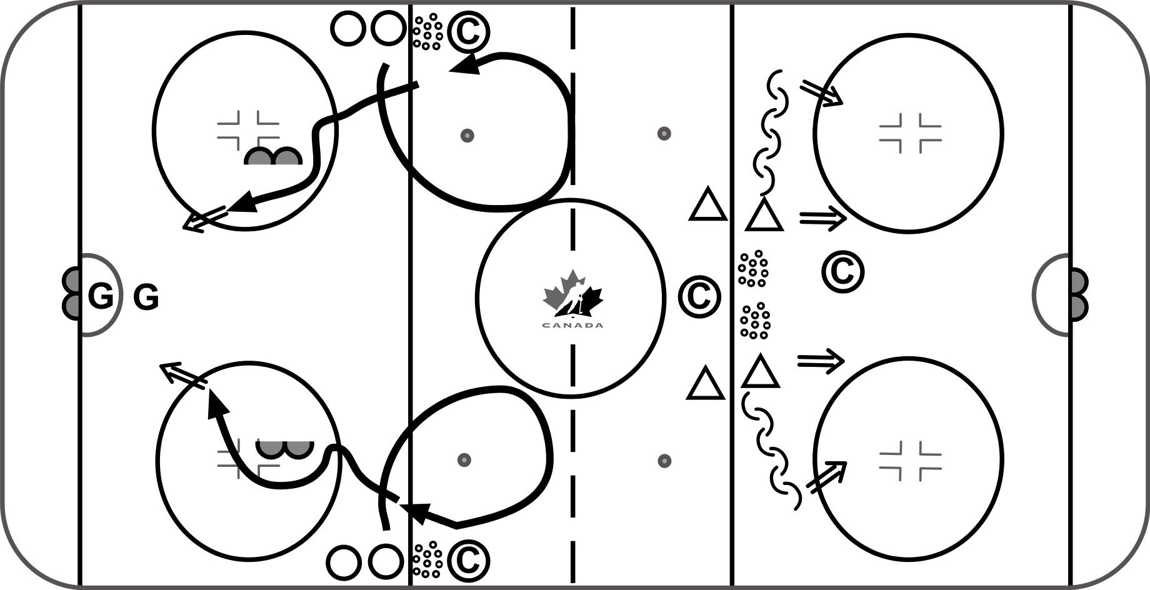
12 mins – Skill Splits
- Forwards – Entries – Overspeed Moves
-Players start along the boards inside the blue line.
-Skate out from the boards into NZ and then perform a few quick crossovers to turn back. Can also pass puck off boards to self prior to entering zone
-Turn head, scan before turning toward offensive zone
Forward Entry sequences involved:
- Heel skating across blueline - navigate
- Reverse Open ups
- 2 hands to 1 hand separation (use backhand shot option)
- 1 crossover – inside / outside fakes

- Defence – Shooting Sequence
-Place 2 or 3 piles of pucks inside blue line (Shoot 3 - 5 pucks for each skill)
- Stationary quick release pulls (drag)
- Stationary quick release pushes
- Pull to inside, push back to outside shot
- Push to outside, stop bhd drag back to inside shot
Key Teaching Points |  | Key Evaluation Points
Forwards  -Use crossovers to turn quickly  -Pick up the puck in stride to quickly enter the offensive zone  -Sell the fake on the obstacle with the head and shoulders | Defence  -Eyes, up, look at target  -No Dust, Quick release | Forwards  -Accelerate out of turn in NZ  -Eyes up, loading puck  -Spatial awareness, (gap on coach)  -Evasiveness and separation to create shot lane | Defence  -Ability to move laterally - Push or Pull  -Ability to shoot with eyes / head up  -Ability to find open lane  -Look for overhandling the puck.  -Clean / efficient handling of puck

